Call for Papers

For presentation at the
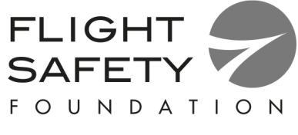

67th annual International Air
Safety Summit (IASS)

Abu Dhabi, UAE

November 11-13, 2014

The International Air Safety Summit will focus on solutions to safety challenges that will have a positive impact on aviation operations. Abstracts selected will be for individual presentation or for participation in panel discussions. Papers should have international applicability and address current issues.
Topics Sought

Papers submitted on other appropriate subjects will be considered

- Flight deck automation (training and design)
- Safety successes from low cost carriers
- Effective use of safety data
- The process of moving from reactive to predictive safety
- Aviation workforce – growing the next generation of aviation professionals
- Understanding and preventing noncompliance of policies and procedures
- Review of accident investigations
- Cognitive strategies for flight deck awareness
- The role of social media in safety
- The effective use of approved PED’s on the flight deck
- The effects of regional culture on CRM (crew resource management) effectiveness
- Lessons learned from regional safety groups
- Integration of safety risk management in the organization
- Evolving the regulator to balance prescriptive and performance based philosophies
- Tactical decision making in operations (e.g. flight, ground, maintenance) – methods and techniques
- Lessons learned from EBT (evidence based training) programs
- Sharing experiences from risk assessment modeling
- Lessons learned from FRM (fatigue risk management)
- Runway excursions
- Developing effective policies and procedures
- Safety data and information sharing at operator, country, regional, and global levels
- Simple and inexpensive safety solutions
- MPL (multi-crew pilots license)
- Safety initiatives for lithium battery transportation
- Regulator perspective of implementation of SSP (state safety program) and SMS (safety management systems)
- Child passenger safety

Abstracts must be received at the Flight Safety Foundation by April 18, 2014

Call for Papers

For presentation at the
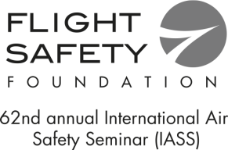

67th annual International Air
Safety Summit (IASS)

Abu Dhabi, UAE

November 11 - 13, 2014

I wish to present a paper at the FSF Safety Summit and have enclosed a brief (1 page) abstract of the proposed paper, plus a résume or curriculum vitae (cv) of no more than 1 page.
Author Name (Print):
Paper Title:
Organization:
Position:
Mailing Address:
Name/Organization:
Street/Building/Suite:
City/State/Country/Zip/Postal Code:
Telephone:
Fax:
Email:
• Abstracts must be submitted to Flight Safety Foundation by April 18, 2014
• Papers will be selected on the basis of content and applicability
• Each author will be responsible for their own travel and accommodation costs. Each author will receive complimentary seminar registration.
• A transfer of copyright to the Foundation is required for each paper selected for presentation at the seminar. Submittal of an abstract or paper implies agreement that the author shall transfer copyright to the Foundation.
Complete this form and return it by 18 April, 2014 to:
Flight Safety Foundation:
Email: technical@flightsafety.org Fax: +1 703 739 6708

For a copy of this form please visit our World Wide Web site at http://www.flightsafety.org

