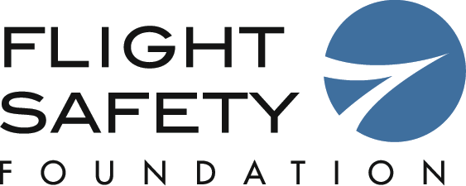

FOR IMMEDIATE RELEASE
Contact: Emily McGee
Director of Communications
+1 703-739-6700 (ext.126)
mcgee@flightsafety.org
66th Annual IASS in Washington, Keynote Speaker Announced

Alexandria, VA, September 24, 2013 – The Flight Safety Foundation announced today that the Honorable Earl Weener, board member of the National Transportation Safety Board, would be giving the key note speech at its 66th annual International Air Safety Summit (IASS) on October 29 at the Omni Shoreham Hotel in Washington, DC.

Dr. Weener’s speech, entitled “Is Safety Cyclical,” will address the fact that while safety in the industry is always improving, some accident causes that were considered to be adequately addressed seem to recur, often unexpectedly.

“This year’s IASS in Washington, DC has a packed agenda addressing the most pressing issue facing aviation today,” stated FSF President and CEO Kevin Hiatt. “Dr. Weener’s keynote speech will set the stage for 3 days of presentations and panels deeply diving into aviation safety.”

Other topics on the IASS agenda include the status of the FSF Go Around study, a review from the BAE’s Air France 447 investigative team, a look a maintenance issues, safety management updates, safety data analysis and sharing as well as presentations from safety experts from around the world on other topics. Dave Barger, CEO of JetBlue, will give a talk on the last day on safety from the airline perspective.

The IASS was first held in 1947 when FSF was founded and it travels around the world each year. This is the first time it has been in Washington for more than 10 years. The meeting starts the morning of October 29 and runs through October 31. Full information and registration information can be found at www.flightsafety.org/iass. The summit is also open to the media but requires pre-registration by contacting Emily McGee at mcgee@flightsafety.org.
###
Flight Safety Foundation (www.flightsafety.org) is an independent, non-profit, international organization engaged in research, education, advocacy and publishing to improve aviation safety. The Foundation’s mission is to be the leading voice of safety for the global aerospace community.

