|  |
| --- |
| **TERPS vs. PANS-Ops Instrument Procedure Design and Operational Differences:  They Are the Same, Only Different**  *Guy D. Gribble*  *International Flight Resources* |

In the world of instrument procedure design, an individual country (sometimes referred to as “State”) can choose one of two worldwide design standards, something of their own design or any combination of any part of the three. The two standards in the widest use are the International Civil Aviation Organization’s (ICAO’s) Procedures for Air Navigation Services, Aircraft Operations (PANS-Ops) and the Federal Aviation Administration’s United States Standard for Terminal Instrument Procedures (TERPS). Physics, aerodynamics and mathematics are the same worldwide. This is the only simple part to a comparison of PANS-Ops and TERPS. Individual states do *not* have to publish any notice of the differences with ICAO. The Aeronautical Information Publication (AIP) of the State is the source document of a country’s aviation information and procedures. Once inside a country’s borders or territories, what they publish becomes directive. The state is the approving entity and will flight check, maintain, publish, and update the procedure as needed.

**Measurement Comparisons**

Measurements in PANS-Ops are primarily published in International System of Units, metric, i.e., meters and kilograms. TERPS measurements are in US customary units, mercian, i.e., feet and pounds. Allowances for fix tolerances, flight technical error, wind drift, instrument errors and in some cases altimeter errors are integrated into procedure design. Rounding of the final numbers calculated is very similar. Terrain/obstacle location and dimensions are derived from State approved sources. Compliance to the World Geodetic System 1984 (WGS-84) ICAO standard will vary. Individual country AIPs will need to be referenced to find which coordinate datum is used inside that country and at that particular airport.[1]

**Departure End of Runway**

The starting point in PANS-Ops and TERPS is at the departure end of runway (DER). This is the same term *but* is defined significantly differently. In PANS-Ops, DER can be the last portion of the runway suitable for takeoff or, if a clearway is used, the DER is “moved” to the end of the clearway and the highest elevation of the runway or clearway is used. TERPS specifically defines DER as the “end of the runway available for ground run of an aircraft.” The height used may be the height of the DER or as high as 35ft above it. The difference is based upon what the procedure designer needed. To make it more confusing, later changes in TERPS start terrain/obstacle evaluations at the more restrictive 0ft DER.

**Required Climb Gradients**

At the DER, PANS-Ops will add 5m/16ft and begin an upward slope of 2.5% to create an obstacle identification surface (OIS). Add to this .8% to ensure a minimum obstacle clearance (MOC). This will result in a 3.3% standard procedure design gradient (PDG). This gradient is used until the next phase of flight minimum obstacle clearance is met. Operationally, pilots know this as the MEA, MOCA, Grid MORA or minimum holding altitude.[2]

TERPS uses an obstacle climb surface (OCS) for this same purpose. OCS slopes upward at 152’/NM or 40:1 ratio. On top of this surface is added the required obstacle clearance (ROC). ROC slope is 48’/NM. Add the OCS to ROC and this becomes the familiar 200ft/NM standard. ROC increases along this slope until the next phase of flight minimum obstacle clearance is met. Just like in PANS-Ops, pilots know this as the MEA, MOCA, Grid MORA or minimum holding altitude. [3]

In both PANS-Ops and TERPS the net takeoff flight path clears all obstacles by a vertical distance of at least 35ft. Commercial operators have an additional horizontal requirement of 200ft laterally inside the airfield boundary and 300ft laterally outside the airfield boundary. TERPS/PANS-Ops does not define a requirement; operational regulations found in inside 14 CFR Part 121/135 does this. In a similar method, ICAO Annex 6 and EU-Ops defines lateral obstacle separation as 90m/295ft plus .125 times the distance from the DER.[4]

**Departures, Horizontally Speaking**

Both PANS-Ops and TERPS begin the horizontal evaluation of obstacles at the DER as described above. The initial width is 150M/500ft on either side of the runway centerline and splays 15° outward from both sides. This space on the departure is defined in PANS-Ops as “Area 1” and it extends 3.5Km/1.9NM. The length of this splay in TERPS is normally 2 NM but may be longer or shorter for early turns, a climb gradient required to a particular altitude/height, or a combination of both. TERPS labels this the initial climb area (ICA). [5]

**What if a Straight-Out Departure Won’t Work?**

Procedure designers have only a few options to compensate for local conditions and create a safe departure climb/path. The solutions fall into the broad categories of:

* Climb faster over the problem obstacle, *and/or*
* Turn away from the problem obstacle, *and/or*
* Keep the problem insight and tell the pilot to “see and avoid” it, *and/or*
* Climb IMC in an area away from the problem and tell the pilot where this area is.

To climb faster, TERPS may require pilots to use a shorter ground run and earlier lift-off point on the runway via a displaced threshold and reduced takeoff run available (TORA) distances. A higher than standard climb gradient (>3.3%/200’ per NM) may also be required. TERPS will use only one such climb gradient all the way to an MEA. PANS-Ops will require this increase until MOC, then reduced to the standard climb gradient until at a published MEA.[6]

To “see and avoid,” TERPS uses a climb in VMC conditions and conspicuous obstacle markings/lighting before allowing IMC entry. A “visual climb over airport” procedure will specify a minimum altitude and/or routing to cross over the airport or fix. Procedure designers use a standard 40:1 climb gradient for obstacle identification and ROC.[7] Greater than standard climb gradients may be directed in a particular sector or departures restricted to VMC conditions until minimum obstacle clearance is met.

PANS-Ops uses a procedure known as an omni-directional departure. This includes “Area 1” we previously discussed and adds “Area 2” and “Area 3.” Area 2 begins at the end of Area 1 and splays outward at 30º. Area 2 ends at the point from which a pilot may turn greater than 15º in any direction and not impact terrain or obstacles using the standard climb gradient of 3.3%. To define the required obstacle identification surface (OIS) for Area 3, a circle around the airport is drawn. The distance of this circle is the distance from 600m/1970ft from the approach end of the departure runway until minimum obstacle clearance is met using 3.3% climb gradient. [8]

**When the Unexpected Is Happening**

TERPS and PANS-Ops are for normal operations with all engines functioning, maintaining both the ground track and the required climb gradient until MEA. The “guarantee” of terrain and obstacle separation is only good while on the departure’s track and complying with the departure’s climb requirements. Abnormal circumstances are not accounted for. To illustrate the problem, assume a two-engine jet transport, engine failure on the runway and climbing up to 1,500AFL. The best climb gradient this aircraft is certified to perform is a NET 1.6%. Compare this to the standard climb gradient of 200’/NM or 3.3%.

The operational pilot must also consider the effects of:

* The pre-/post-1998 screen height differences 15ft or 35ft?
* Variable DER start positions for obstacle evaluation
* Procedure designer’s latitude in requiring more restrictive climb and maneuvering
* Aircraft certification standards only to 1,500AFL and not the operating MSA

It is easy to understand the need for pilots and operators to develop their own contingency procedures. This is universally applied inside TERPS and PANS-Ops.[9]

**A Word About Minimum Safe and Minimum Sector Altitude Definitions**

PANS-Ops will define MSA as a minimum SECTOR altitude. TERPS will define the same MSA as a minimum SAFE/SECTOR altitude. Both criteria define this as the lowest altitude that ensures at least 300m/1000ft of terrain and obstacle separation within 25NM from the NAVAID or waypoint defined. Interestingly, the FAA’s Aeronautical Information Manual directs that the MSA is for “emergency only” use and does not “guarantee” NAVAID reception. PANS-Ops and EU-Ops do not specify “emergency only” usage and make no mention of NAVAID reception.[10]

**PANS-Ops Entry Sector Defined**

PANS-Ops directs that course reversal procedures utilize an entry sector. This is a cone of protected airspace from which to begin the outbound leg of the course reversal procedure. This cone is defined as within ± 30° of the outbound reversal track. The entry sector is not published on the approach plate nor contained in the flight management computer (FMC) database. Pilots are responsible for determining where the entry sector exists. During this initial and intermediate segment, holding pattern type protected airspace is provided. See the diagram below.

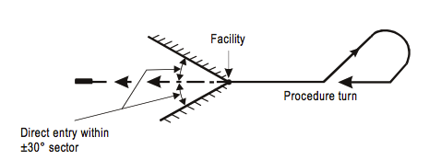

In some cases pilots may request “maneuvering airspace” to perform an alignment maneuver. Such requests are often met with confusion by ATC. Specific terminology, accurate situational awareness and terrain/obstacle avoidance become the pilot’s responsibility in these cases.

Procedure designers can incorporate a holding pattern for maneuvering airspace into this entry sector. The key to this is that the inbound leg of the holding pattern must place the aircraft inside the procedures’ entry sector. PANS-Ops refers to this as an omni-directional arrival. See the diagram below.[11]

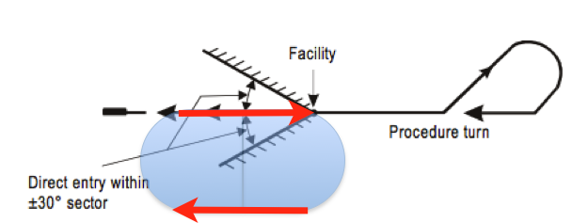

**TERPS Alignment Maneuvering**

TERPS does not mandate the use of an entry sector and makes no distinction between “standard” or “omni-directional.” Instead, TERPS provides protected airspace on the non-maneuvering side of the defining NAVAID. Please see the diagram below. [12]

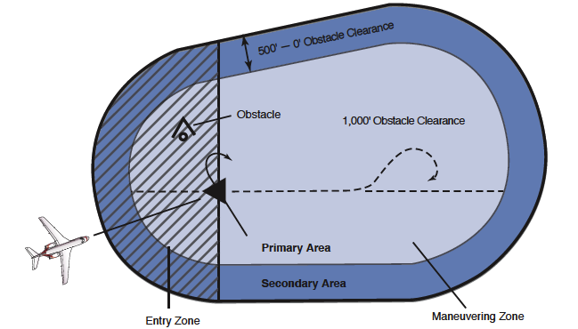

**Airspeed and Descent Parameters**

PANS-Ops initial and intermediate segments are designed for a maximum of 240 KIAS, Approach Category “C.” TERPS is mute on the subject of maximum speeds. The FAA’s Instrument Procedures Handbook (IPH) directs that 200KIAS be used after “first over-heading the course reversal IAF.” PANS-Ops procedure designers will use a maximum descent rate of 1,200FPM outbound and 1,000FPM inbound. TERPS designers use 250’/NM as an optimum descent gradient. At 200KIAS this is about 825FPM. [13]

**Course Reversal Procedures**

Below here is a chart describing the course reversal procedures referred to in PANS-Ops and TERPS.

**TERPS**

45/180

80/260

Teardrop

Turn

Holding

In-Lieu-of

Procedure

Turn

**PANS-Ops**

45/180

80/260

Base Turn

Racetrack

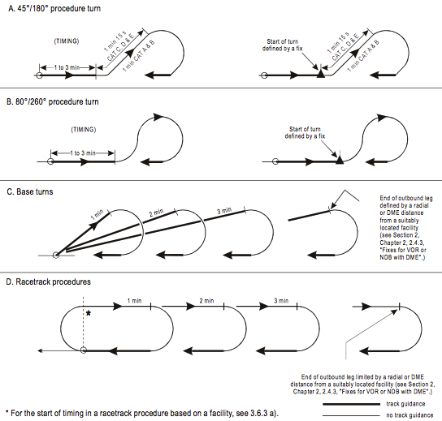

**Procedure Turns**

PANS-Ops does not direct which procedure turn to use *unless* there is a specific note to use only one. TERPS will specifically depict which one to use. If only a “barbed arrow” is printed in TERPS, it indicates the protected airspace side of the procedure. Only in this case has TERPS allowed for a pilot’s choice of procedure turn. Neither TERPS nor PANS-Ops permit procedure turns to be interchanged with a base turn/teardrop or holding/racetrack procedures. Another significant operating difference is, TERPS uses a “remain within xx miles” and the pilot assumes responsibility to remain within protected airspace. PANS-Ops defines a turn point specifically by the amount of time, distance or fix crossing.[14] Please see the examples below.

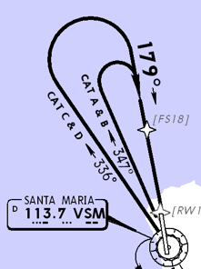

**Racetrack and Hold-in-Lieu-of Procedure Turn**

This procedure looks very similar to a standard holding pattern but it is not. Both PANS-Ops and TERPS make it clear that one “overhead” is used to align the aircraft and configure for landing. Upon the next overhead, the aircraft is expected to continue with the approach and *not* turn outbound again. The pilot would need to coordinate with ATC for additional “circuits.”[15]

**Visual Approach vs. Visual Maneuvering**

A visual approach is an IFR clearance executed by visual reference to terrain. The pilot assumes responsibility for terrain and obstacle clearance. No specific weather requirements are published but current weather conditions must “reasonably ensure” continued VMC to the airport. [16]

A visual approach to a particular runway with specific ground tracks and altitudes required becomes “visual maneuvering.” Roads, water features and mountain passes are examples of referenced terrain features. These approaches are designed with a straightaway leg to the “landing runway” that is no shorter than .5NM.[17] No one standard or practice is mandated in the application of guidance light usage. Examples of helpful guidance/lead-in lights are at KJFK for runways 13L/R and at LPMA Funchal, Madeira, Runway 05.[18]

**Circling-to-Land Approaches**

A circling approach will be specified in those cases where terrain, final approach track alignment or a steep descent gradient does not allow for standard PANS-Ops and TERPS criteria. Operational situations at a particular airfield such as wind conditions or runway closures may direct landing on other than the runway approached. Circling approaches are designed with a short straight leg to the “landing runway.”[19] The risk associated with a circling approach is much higher than that for other types of approaches. The Flight Safety Foundation’s Controlled Flight Into Terrain and CFIT studies have shown that runway-aligned approaches are 25 times safer than circling approaches.[20]

PANS-OPS and TERPS define the limit of obstacle evaluated airspace is by drawing an arc from the center of the approach threshold of each usable runway. The radius of the arc depends on airfield altitude, aircraft indicated air speed, wind, bank angle used and flight technical tolerances. Both criteria perform an additional calculation and compare the MOC/ROC of the circling area to the airport elevation plus the MOC/ROC and derive height above airport altitude, HAA. The higher of the two values determined will be published as the required “circling minimums.”[21] Not all countries will be 100% PANS-Ops or TERPS. For example: a straight-in approach may be designed to PANS-Ops, then, circle-to-land inside a TERPS evaluated area. Mexico, South Korea and Chile are examples of this situation. To further complicate this matter, the TERPS evaluation may be done to the older pre-Change #21 criteria.

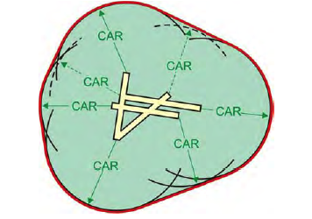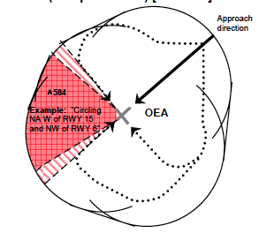

In the table below I compare circling minimum visibility, minimum altitudes/heights and obstacle evaluated arcs. Generally speaking, when compared to PANS-Ops, TERPS will circle at a lower minimum altitude/height, closer to the landing runway’s threshold and at a slower speed. The circling area defined by TERPS prior to Change #21 (June 2009) will be much smaller in size. To the operational pilot, it is not immediately clear whether published procedures have been revised to reflect that latest change of TERPS.

**PANS-Ops**

Acft Cat Min Vis MOC/HAA Max Speed/ºAOB 2 x Radius + Straight

A 1.0 NM 295/ 394 ft 100 KIAS/20º 1.38+.3 = **1.68 NM**

B 1.5 NM 295/ 492 ft 135 KIAS/20º 2.26+.4 = **2.66 NM**

C 2.0 NM 394/ 591 ft 180 KIAS/20º 3.70+.5 = **4.20 NM**

D 2.5 NM 394/ 689 ft 205 KIAS/20º 4.68+.6 = **5.28 NM**

E 3.5 NM 492/ 787 ft 240 KIAS/20º 6.24+.7 = **6.94 NM**

*At 2000’MSL, ISA+15 and 25KTS of added wind. NOTE: Visibility in nautical miles vice statute miles.* [22]

**TERPS**

Acft Cat Min Vis ROC/HAA Max Speed/ºAOB OEA Radius+Straight=CAR*

A 1.0 SM 300/ 350 ft 90 KIAS/25º .88+.4 = **1.30 NM** min

B 1.0 SM 300/ 450 ft 120 KIAS/25º 1.31+.4 = **1.71 NM**

C 1 ½ SM 300/ 450 ft 145 KIAS/20º 2.18+.5 = **2.68 NM**

D 2.0 SM 300/ 550 ft 165 KIAS/20º 2.89+.6 = **3.49 NM**

E 2.0 SM 300/ 550 ft 200 KIAS/22º 3.65+.7 = **4.35 NM**

*With Change #21 and later, at 1000’MSL, ISA Standard and 25KTS of added wind. Visibility in statute miles. OEA= obstacle evaluated area, *CAR= circling area radius (1.3NM minimum)[23]*

**Circling/Visual Maneuvering and Required Visual Reference**

The basic assumption is that the runway environment (i.e., the runway threshold or approach lighting aids or other markings identifiable with the runway) must be kept in sight while at the MDA/H for circling. If the procedure designer derives minimums of 1000 ft/3SM or greater, a requirement to “fly visual to the airport” may be published vice circling minimums. [24] In this case the discussion, “Visual approach vs. Visual Maneuvering” on page 10 would apply.

**Circling, When to Descend**

If using circling minima, do not leave the MDA/H until intercepting the nominal approach angle is a common operating assumption inside both PANS-Ops and TERPS. If the operation is a commercial one, pilots *must* maintain the MDA until the runway threshold has been positively identified and a normal glide path can be maintained to a landing in the touchdown zone, TDZ.[25]

To aid in obstacle clearance during the straight-in visual landing portion of an instrument approach, PANS-Ops uses a visual segment surface, VSS. This is new to instrument approach procedures designed to PANS-Ops criteria since 2007. TERPS will establish a visual descent area and a visual descent point for non-precision approaches. A visual descent area, VDA is applied to all runways where circle-to-land is authorized. The VDP defines a point on an NPA procedure from which normal descent from the MDA may be commenced, provided the required visual references have been acquired.

**Missed Approaches**

The missed approach procedure is assumed to start no lower than the published OCA/H or MDA/H at the missed approach point, MAP. Pilots utilizing a constant descent final approach, CDFA, procedure are required to initiate the go-around at an altitude above the MDA/H to ensure the aircraft does not descend below the published MDA. This is sometimes referred to as a derived decision altitude, DDA.[26]

PANS-Ops missed approach initial segment starts at the MAP and ends 15 seconds later. This phase is level and has the same MOC as the final approach segment. Significantly different, TERPS makes no allowance for level flight or aircraft configuring. Compare the diagrams below. 2.5% is the standard missed approach climb gradient. For obstacle avoidance PANS-Ops may specify a non-standard climb gradient for a missed approach. TERPS will use an increase in MDA/H to alleviate obstacle hazards vice higher than standard gradients.[27]

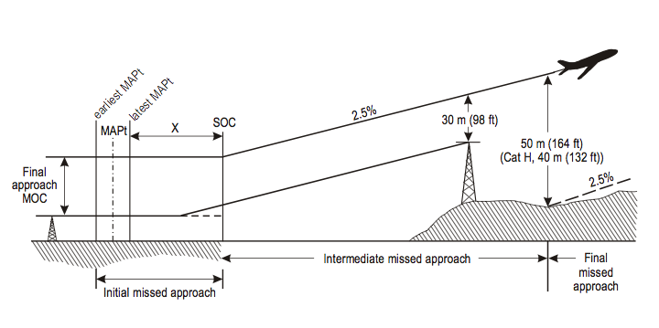

**PANS-Ops**

**TERPS**

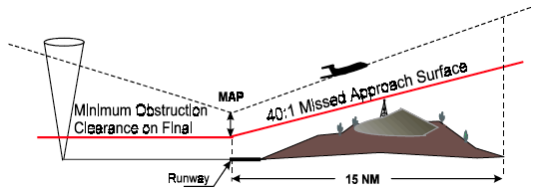

**Conclusions and Summary: Pre-Flight Planning**

* ICAO makes standards and recommendations for States to follow. Individual countries may accept, reject or modify them at will.
* States may or may not publish their procedure differences from ICAO.
* State’s Aeronautical Information Publication is *the* information source inside *that* country and its territories.

**Departures**

* PANS-Ops and TERPS use the same climb gradient but start from different points, neither of which are where or how the aircraft is certified from in the event of an engine failure.
* Neither PANS-Ops nor TERPS account for abnormal conditions like engine failure and non-normal aircraft configuration.
* Individual airport and runway analysis may not account for ground track and obstacle/terrain clearance from the aircraft’s present position.

**Arrivals/Course Reversals**

* ICAO procedure maximum speeds are very different from TERPS.
* Specific procedure turns are mandatory in TERPS, unless just a “barb” is depicted, and then it is a pilot’s choice.
* In Pans-Ops, procedure turn selection is a pilot’s choice unless specifically prohibited in the approach procedure.
* Base turns/teardrop may never be substituted for procedure turns.
* MSA has a different meaning in PANS-Ops and in TERPS.
* Flight and ground track has increased importance in PANS-Ops.

**Approaches**

* A PANS-Ops NPA has about half the protected airspace as TERPS.
* A “visual approach” is different from “visual maneuvering” and both are different from a “circle-to-land” approach.
* ICAO circle-to-land places the aircraft higher, faster and farther away from the landing runway than TERPS.
* Circling-to-land, TERPS and PANS-Ops have the same visual clues and visual requirements.
* When using a CDFA technique for NPA final approach descent, the MDA/H must be artificially increased by the pilot to keep within protected airspace.

**Missed Approach**

* Maximum speeds apply in both PANS-Ops and TERPS but are different numbers.
* PANS-Ops allows for a level acceleration, TERPS does not.
* Both PANS-Ops and TERPS end with a holding pattern, MEA or MSA altitude.

**About the Author**

Guy Gribble is General Manager, International Flight Resources, and an international first officer, B-767/757, ATP, CFI, CFI-I, CFI-ME.

In 1984, Guy entered U.S. Navy flight training at Pensacola, Florida, and later was qualified as an A-6 Intruder attack pilot. He was competitively selected to serve on the U.S. Navy’s only forward deployed carrier, *USS Midway*, CV-41.

Guy was hired by American Airlines in 1992 and has held co-pilot positions on the McDonnell Douglas DC-9 and the Boeing 767 and 757. He was initially assigned international bid status in 1998 and then was awarded Captain on the DC-9 in 2000. Returning to the B-767/757 in 2001, he has operated internationally since. With this current assignment he regularly operates to Europe, South America, Central America, in the Caribbean and the Hawaiian Islands.

International Flight Resources is a pilot-focused information services and training provider emphasizing international operations and human factors training. International Flight Resources specializes in presenting topics such as risk management in oceanic crossing, international operating procedures, fatigue management, PANS-Ops vs. TERPS differences and datalink function/operation. Guy has presented these topics at the NBAA International Operators Conference, Bombardier Safety Standdown and for the Flight Safety Foundation.

**References and Graphics Credits**

1. ICAO Annex 11, Paragraph 2.28, “Common Reference System”

   ICAO Annex 14, Paragraph 1.3, Common Reference System”

   NOAA FAQ’s on WGS-84, <http://www.ngs.noaa.gov/faq.shtml>
2. PANS-Ops Volume 2, Part 1, Section 3, Chapter 2, “Design Principles”

   FAA’s Instrument Procedures Handbook, FAA-H-8261-1A, Chapter 2, Page 2-12, “Design Criteria”
3. TERPS Volume 4, Chapter 1, “General Criteria”
4. 14 CFR 121.189, 135.379, EU-Ops 1.495

   ICAO Annex 6, Part 1, Attachment C, Para. 5, “Take-off Obstacle Clearance Limitations”
5. TERPS Volume 4, Chapter 1, Paragraph 1.6, “Initial Climb Area”
6. PANS-Ops Volume 2, Part 1, Section 3, Chapter 2, Para. 2.7, “Procedure Design Gradient”

   TERPS Volume 4, Chapter 1, Paragraph 1.4.4 “Multiple Climb Gradient Application”
7. PANS-Ops Volume 2, Part 1, Section 3, Chapter 4, “Omnidirectional Departures”

   TERPS Volume 4, Chapter 2, “Diverse Departures”
8. PANS-Ops Volume 2, Part 1, Section 3, Chapter 4, “Omnidirectional Departures”

   TERPS Volume 4, Chapter 2, “Diverse Departures”
9. Runway lift-off to Landing Gear retracted is Segment#1; Landing Gear retracted to Flaps

   retracted is Segment #2 and from Flaps retracted to no lower than 1500’AGL is Segment#3.

   For any two-engine jet transport aircraft, the first segment has a minimum climb gradient of just “Positive Climb”.03% The screen height at DER is 35ft. Later certification (post 1998) criteria mandate a wet runway certification and use a 15ft screen height vice 35ft.

   The second segment GROSS climb gradient for certification must be 2.4% for a two-engine aircraft. During this segment the NET flight path must clear any obstacle by at least 35ft. The minimum speed of V2 to a height of no lower than 400 feet above the takeoff surface or at a height that may be necessary to achieve obstacle clearance is mandated. The required GROSS gradients are further reduced to achieve this NET gradient. This reduction from the gross is 0.8% for a two-engine aircraft. This will result in the familiar 1.6% two-engine second segment NET climb gradient. Third segment, the aircraft has reached the acceleration altitude and will climb to no lower than 1500AGL. It must have a gradient climb equivalent of 1.2% for twin-engine aircraft, 1.4% for three engine aircraft and 1.5% for four engine aircraft.
10. TERPS Volume 1, Chapter 2, Paragraph 221, “Minimum Safe/Sector Altitudes”

    ICAO Annex 4, Chapter 1, Appendix 2 “Minimum Sector Altitude”

    Aeronautical Information Manual, Paragraph 5-4-5c “Minimum Safe/Sector Altitude”
11. PANS-Ops Volume 1, Part 1, Section 4, Chapter 3, Para. 3.3.1 “Entry”
12. TERPS Volume 1, Chapter 2, Paragraph #234, “Initial Approach Segment Based on a PT”
13. PANS-Ops Volume 1, Part 1, Section 4, Table I-4-1-2, “Speeds for Procedure Calculation in

    Knots”, Category C/D Speeds for Initial Approach

    PANS-Ops Volume 1, Part 1, Section 4, Table I-4-1-3, “Rate of Descent in the Final

    Approach Segment, w/o FAF”

    TERPS Volume 1, Chapter 2, Paragraph #234, “Initial Approach Segment Based on a PT”

    FAA’s AIM Chapter 5, Paragraph 5-4-9, “Procedure Turn and Hold-in-lieu of Procedure

    Turn”
14. PANS-Ops Volume 1, Part 1, Section 4, Chapter 3, “Initial Approach Segment”

    FAA’s AIM Chapter 5, Paragraph 5-4-9, “Procedure Turn and Hold-in-lieu of Procedure

    Turn”
15. AIM Chapter 5, Section 4, Para. 5-4-9,5 “Procedure Turn and Hold-in-lieu of Procedure

    Turn”
16. PANS-ATM, Chapter 6, Paragraph 6.5.3
17. PANS-Ops Volume 2, Part 1, Section 4, Chapter 7, Appendix “Visual Manoeuvering Using

    Prescribed Track”

    TERPS Volume 1, Chapter 2, Section 6 “Circling Approach”

    AIM Chapter 5, Paragraph 5-4-24 “Charted Visual Flight Procedures”
18. ICAO Document #9157, “Aerodrome Standards” Chapter 5, Paragraph 5.3.6, “Circling

    Guidance Lights”

    FAA Order JO 6850.2B, 08/20/10 Visual Guidance Lighting Systems” Definitions#18,

    “Lead-in Lighting System”

    FAA Information for Operators #11003 01/25/11 “Pilots Roles and Responsibilities

    During Visual Approaches”
19. PANS-Ops Volume 2, Part 1, Section 4, Chapter 7

    PANS-Ops Volume I, Part I, Chapter 1, Definitions
20. Flight Safety Foundation, European Advisory Committee Discussion Paper “Circling

    Approaches, Issues Identified”, Draft Edition 24JAN11
21. PANS-Ops, Volume 2, Section 4, Chapter 7

    TERPS Volume 1, Chapter 2, Section 6 “Circling Approach”
22. PANS-Ops, Volume 2, Section 4, Chapter 7
23. TERPS Volume 1, Chapter 2, Section 6 “Circling Approach”

    TERPS Volume 1, Chapter 3, Paragraph 3.3.3 and Table 3-9
24. 14 CFR 91.175, 135.225, 121.651, 125.381

    TERPS Volume 1, Chapter 2, Section 6, “Circling Approach”

    TERPS Volume 1, Chapter 3, Paragraph 3.3.3 and Table 3-9
25. PANS-Ops Volume 2, Part 1, Section 4, Chapter 7. PANS-Ops Volume I, Part I, Chapter 1,

    Definitions.

    14CFR 91.175, 135.225, 121.651, 125.381

    Flight Safety Foundation, European Advisory Committee Discussion Paper “Circling

    Approaches, Issues Identified”, Draft Edition 24JAN11
26. PANS-Ops Volume 1, Part 1, Section 4, Chapter 1, Paragraph 1.7 “Vertical Path Control on

    Non-Precision Approach Procedures”

    EU-OPS 1.430, “Aerodrome Operating Minima-General”

    FAA Advisory Circular # 120-108, 01/20/11, “Continuous Descent Final Approach”

    FAA’s Instrument Procedures Handbook, FAA-H-8261-1A

    Chapter 5, Page 5-30 to 5-31, “Stabilized Approach”
27. TERPS Volume 1, Chapter 2, Section 7, “Missed Approach”

    Figures on pages 3, 4, 5, 8 courtesy of ICAO, Pans-Ops Doc#8168

    Figures on page 5, 7, 8 courtesy of TERPS, FAA Order 8260.3B

    Figures on page 5 courtesy of Jeppeson Sanderson, Inc.