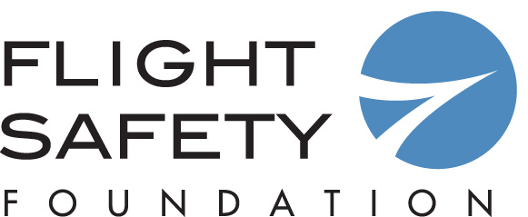

Call for Nominations
FSF Business Aviation Meritorious Service Award

This award, presented by the Foundation since 1975, is for outstanding service and contributions to business aviation safety. The award recognizes individuals whose work has enhanced safety in this segment of the industry. Recipients have included industry leaders, government officials, members of the news media and researchers whose findings were especially relevant to business aviation. The deadline for nominations is March 22, 2019.

The award will be presented at the Foundation’s 64th Business Aviation Safety Summit (BASS 2019), May 2–3, 2019, in Denver. BASS 2019 will be held at the Westin Denver Downtown hotel.

Name of Nominee:

Position/Company:

Address:

Phone/Fax/Email:

***Please attach a one-page document to support your nomination. Nominations without supporting materials may not be considered by the Award Board. ***

Nomination submitted by:

Name:

Address:

Telephone:

Fax:

Email:

Deadline: March 22, 2019
Please return to Frank Jackman at jackman@flightsafety.org
Attention: Flight Safety Foundation – Business Aviation Meritorious Service Award
Thank you for your nomination

