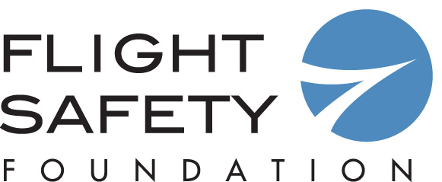

Call for Nominations

FSF-Boeing Aviation Safety Lifetime Achievement Award

Established in 2002, The FSF-Boeing Aviation Safety Lifetime Achievement Award recognizes an individual for his or her lifetime commitment and contribution to enhancing aviation safety. The nominating deadline is Aug. 2, 2019. For more information on the selection criteria, please click here.

The award will be presented at the 72nd annual International Air Safety Summit, Nov. 4–6, 2019, in Taipei.

Name of Nominee:

Position/Company:

Phone/Fax/Email:

***Please attach a one page documentation to support your nomination. Nominations without supporting materials may not be considered by the Award Board. ***

Nomination submitted by:

Name:

Address:

Telephone:

Fax:

Email:

Deadline: Aug. 2, 2019

Please return to Frank Jackman, Flight Safety Foundation, at jackman@flightsafety.org
Attention: FSF-Boeing Aviation Safety Lifetime Achievement Award

