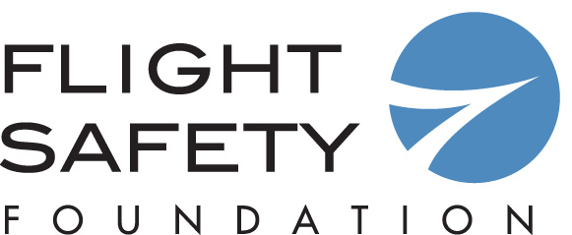

Call for Nominations
Flight Safety Foundation–Airbus
Human Factors in Aviation Safety Award

Purpose and Establishment of Award:

Established in 1999, the Flight Safety Foundation–Airbus Human Factors in Aviation Safety Award recognizes outstanding achievement in human factors contributions to aviation safety. The award may be presented to an individual, group or organization for a one-time contribution or sustained contributions in the field of human factors. The deadline for submitting nominations is Sept. 10, 2018.
The award will be presented at the 71st annual International Air Safety Summit (IASS 2018), Nov. 12–14, 2018, in Seattle, Washington, U.S.

Name of Nominee:

Position/Company:

Address:

Phone/Email:

***Please attach documentation to support your nomination (maximum of one page). Nominations without supporting materials or with materials over one page will not be considered by the Award Board. ***

Nomination submitted by:

Name:

Address:

Telephone:

Email:

Deadline: Sept. 10, 2018
Please return to Frank Jackman, Flight Safety Foundation, by fax 703-739-6708
or by e-mail to jackman@flightsafety.org
Attention: FSF–Airbus Human Factors in Aviation Safety Award
Thank you for your nomination

